Office Guide Copenhagen
Nordhavn, 2150 Copenhagen
Julia Hoffmann · 24 August 2026
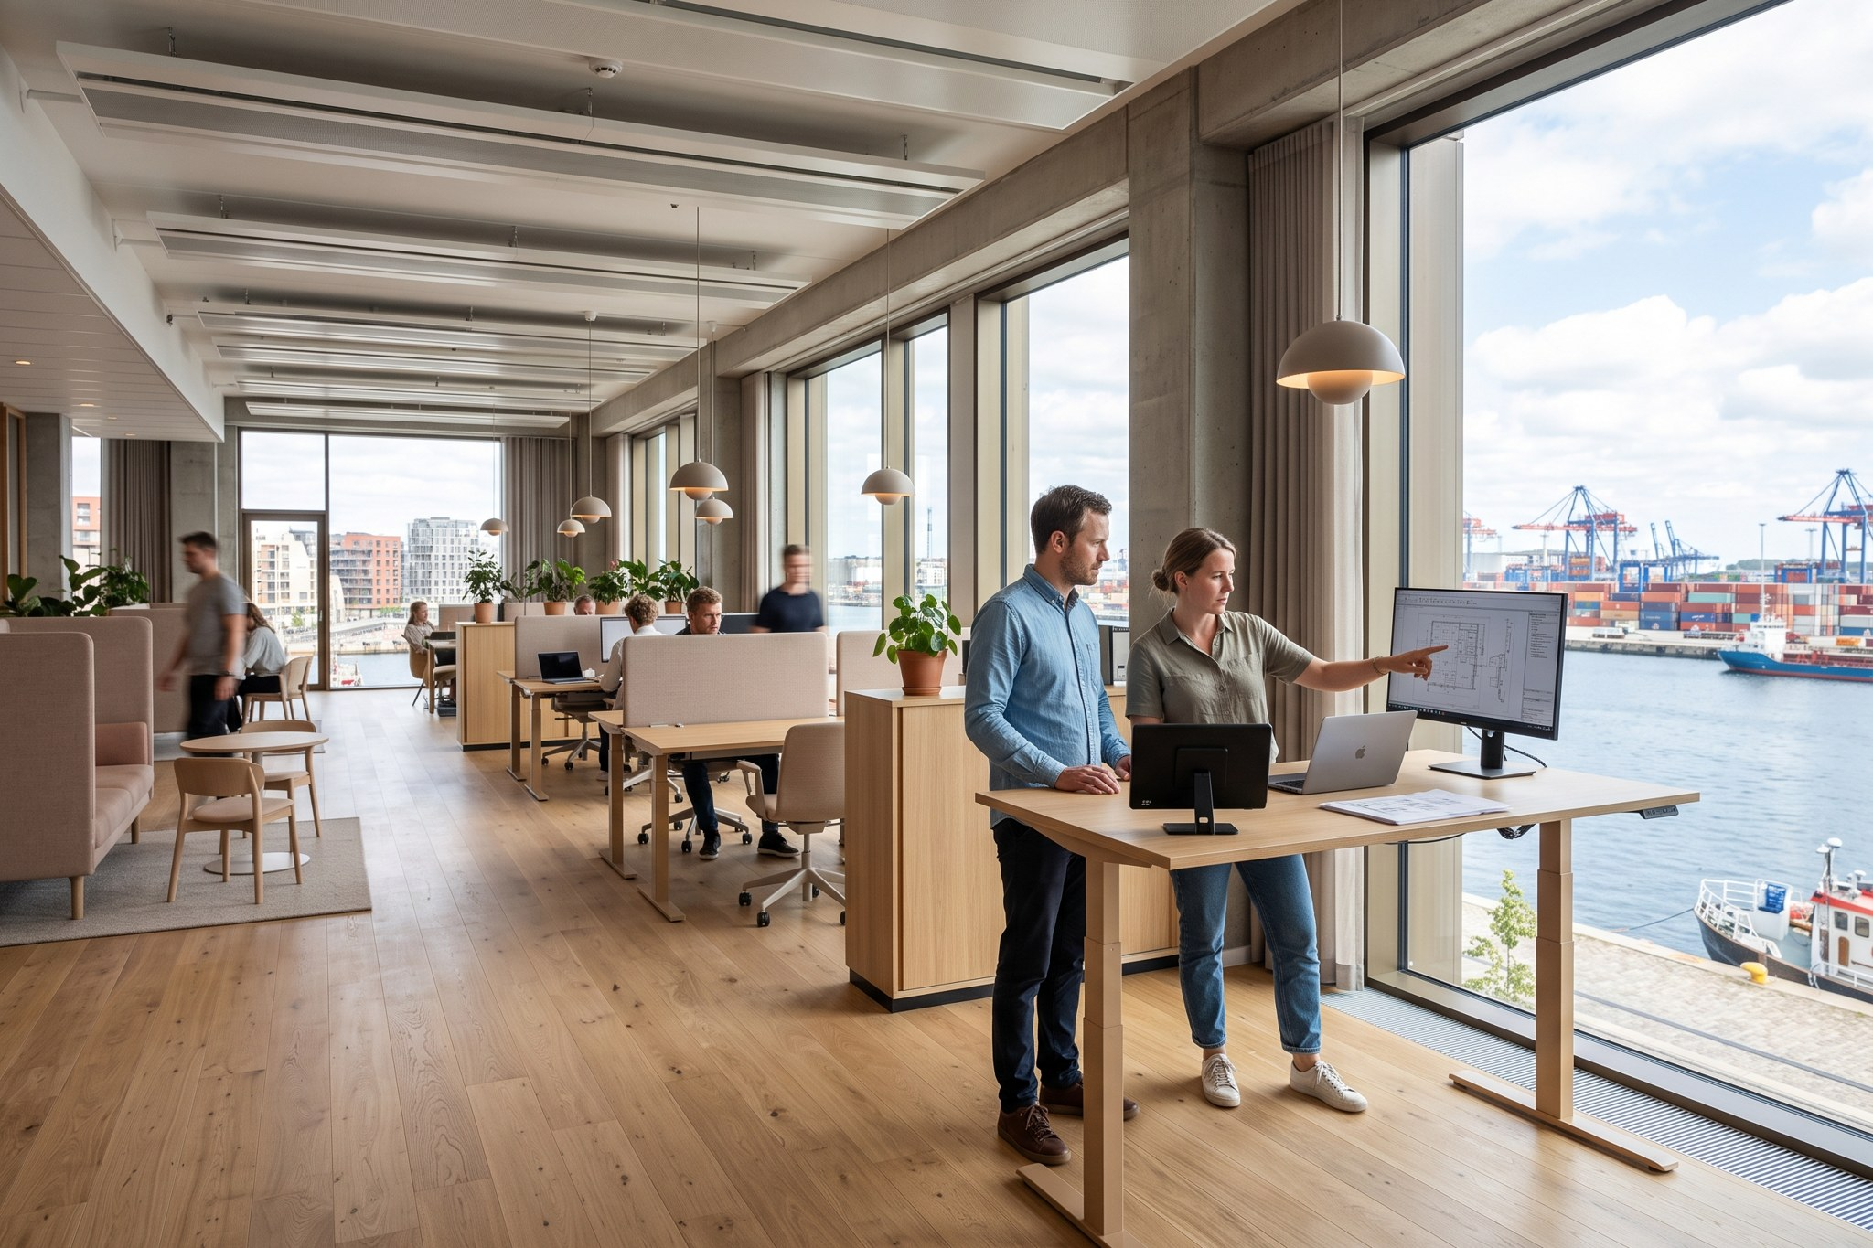
Weyland office Copenhagen
Address: Nordhavn, 2150 Copenhagen

Getting here
Metro M4 Orientkaj (3 min walk) or S-train Nordhavn. Bike parking in front of the building – most of us cycle.

Who sits here
Engineering centre (Sofie Lindqvist): offshore structures, electrical design, geotechnics, SCADA.

Workplace
Open office with focus booths; meeting rooms 'Anholt', 'Horns Rev' and 'Kriegers Flak'.

Food
Shared canteen in the building, lunch scheme DKK 30 per day deducted from salary.

Language
Office language is English; Danish lessons are paid by the learning budget.

Nice to know
Friday 'fredagsbar' at 15:30 on the first Friday of the month.
Emergency: 112. Office first aiders are listed at the kitchen on each floor.

